GoCompare Home Insurance

User Interface Evaluation.

Name: Francesca Andreozzi

Student number: 853175

Contents

1 Abstract 2

2 Methodology 2

3 Strive for Consistency 3

3.1 Consistency of Style 3

3.2 Consistency of Actions 5

3.3 Consistency of Exemptions 5

3.4 Notes for Implementation 6

4 Seek Universal Usability 8

4.1 Accessibility 8

4.1.1 Page Titles 8

4.1.2 Alt Text 8

4.1.3 Headings 8

4.1.4 Zoom Text Only 9

4.1.5 Keyboard Access 9

4.1.6 Moving Content 9

4.1.7 Novice vs Expert Users 9

4.1.8 Notes for Implementation 9

5 Offer Informative Feedback 10

5.1 Minor and frequent actions 10

5.2 Major and infrequent actions 11

5.3 Notes for Implementation 11

6 Design Dialogs to Yield Closure 12

6.1 Sign Posts 12

6.2 Quote Completion 12

6.3 Note for Implementation 13

7 Prevent Errors 13

7.1 User Input Validation 13

7.2 Error Messages 13

7.3 Notes for Implementation 14

8 Permit Easy Reversals of Actions 14

8.1 Notes for Implementation 14

9 Keep Users in Control 15

9.1 Notes for Implementation 15

10 Reduce Short Term Memory Load 15

10.1 Thematic Structure 15

10.2 Existing Details 15

10.3 Notes for Implementation 16

11 Conclusion 16

12 References 16

# Abstract

The Home Insurance user interface (UI) is part of the Go Compare comparison site and provides a platform for users to create home insurance quotes and compare the prices and policies of the partner Companies. The UI respects general standards of stylistic consistency and maintains a minimalist style in line with the brand’s colours and fonts. The chosen style targets a wide range of users. Accessibility standards for keyboard access and reader mark-ups are respected throughout the journey. However, other accessibility features can be improved. Informative feedback is always provided, nevertheless instant error messages could be implemented in certain cases. In addition to that, user input validation is also used to prevent errors. Other types of feedback to communicate closure and progress are provided with the use of sign-posts. However, these could be implemented with more functionality. The user is in control of the details entered and can easily delete and undo actions. However, some questions and confirmations can be redundant especially for experienced users.

# Methodology

This evaluation has established the points of compliance and noncompliance of the UI to the “Eight Golden Rules of Interface Design” by Ben Schneiderman [1]. The title of each sections recalls the relevant rule. The subsection “Notes for Implementation” provides a list of changes which could be implemented in the existing UI. Following is the structure of the user interface (Figure 1).

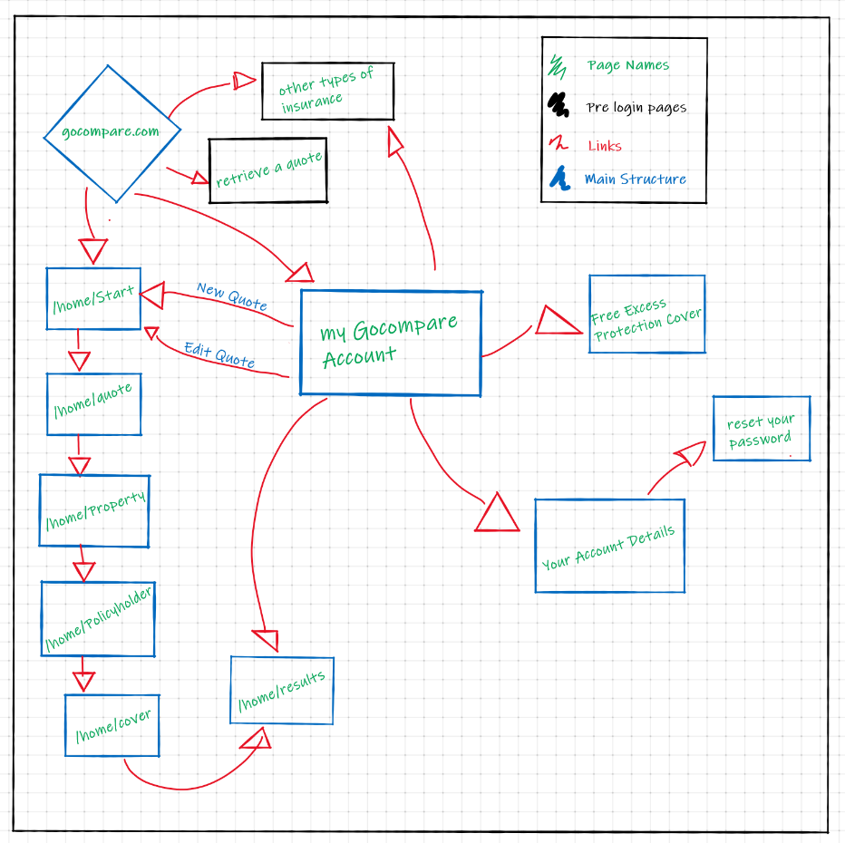

Figure 1: structure of the Home Insurance User Interface

# Strive for Consistency

## Consistency of Style

The Index Page gives several thematic elements which are carried onto the “home insurance[start]” page and are set as recognisable elements of the brand throughout the journey. This suggests to the users that, although they have left the main page and started to complete a form to request Home Insurance quotes, they are still in the Company’s domain, giving an idea of continuity.

The page is aligned on the left of the screen for both Desktop view and Mobile device. The layout is consistent on both devices, with small layout differences dictated by the size of the screen. The page is responsive when resizing the window. The elements which would fall out of the user’s view, are minimized into smaller buttons (Figure 2).

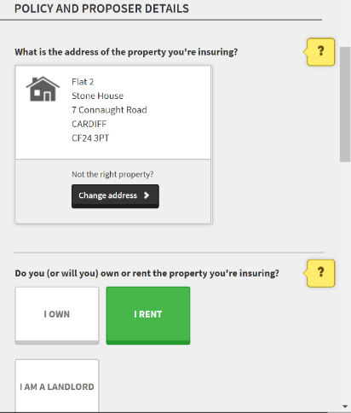

Figure 2: Minimized Help Box. Gocompare.com/home/Start

In the example above, the help boxes which would appear automatically when the user hovers with the cursor over the relevant question are presented as small yellow buttons with question marks to attract the user’s attention.

The main point of interest for the user’s eye is the Company’s colours of choice: #40A434 (apple green) for the background, #3f3f3f (dark grey) for the top header and the text in the navigation menu, and #ffffff white for the body and the main text.

The brand’s main colours, fonts and other stylistic elements are more prominent in the Index Page and are toned down in the “home insurance[start]” page (Figure 3).

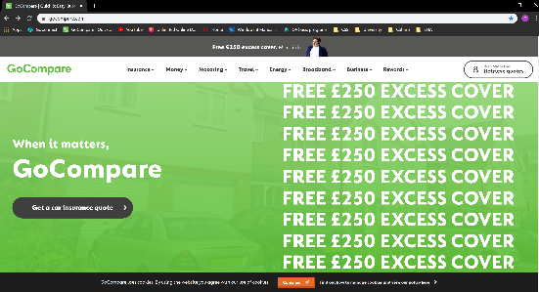 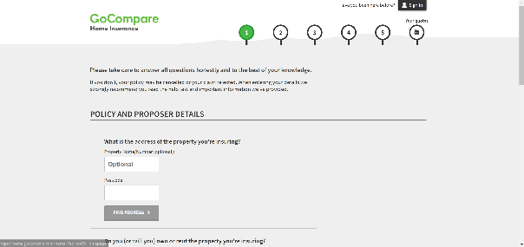

Figure 3: GoCompare.com index page on the right compared to the Home Insurance[start]. Gocompare.com/home/Start

Thanks to the continuity with the Index Page, there is no need to repeat the brand’s characteristic elements in full, which would clutter the page. Instead only subtle reminders to these elements are used for consistency. The Home Insurance interface is a JavaScript form with very specific questions which have an impact on the quotes produced for the customer and have legal value. Keeping the form pages clean helps the user focus on the text. This is important when considering the Functionality of the UI.

In “The Role of Aesthetics in Web Design”, Lisbeth Thorlacius highlights the use of visual effects in conveying the image of the sender [2]. The sender, in this case the Company GoCompare, is the first agent of content [2]. Before the price or the policy details are even shown, the aesthetic value of the web site must gain the user’s trust. The design and stylistic elements of the web site are inevitably part of the UI, but it is only possible to make full use of their abilities if integrated with content and Functionality [2]. The Home Insurance UI integrates functionality with a clean design, where it is easy to obtain the necessary information quickly and efficiently, without having to leave the page. The main content of the UI is always visible to the user. This allows the user to be able to have a constant visual contact with the information necessary to have a clear understanding of the product that they are purchasing, but also with the information that they are providing, which is legally binding (as specified on top of the page (Figure 4)).

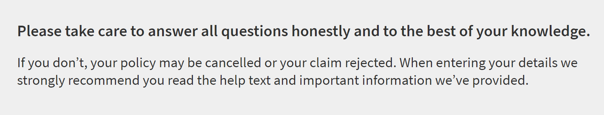

Figure 4: Important information on the top of the start page. Gocompare.com/home/Start

In the “home insurance [start]” page the main body is divided in different sections which contain questions and form fields to complete. The first header introduces the thematic structure of the questions which are aligned on the left of the page and divided by straight dark grey lines. This stylistic choice is consistent throughout the online journey of the Home Insurance UI. It highlights the parent section, which is specified with a title in capital letters, and the subsections which contain the relevant questions in lower case bold writing and smaller size font.

## Consistency of Actions

The user is provided with additional information about each question in a consistent format throughout the journey. This stylistic choice is dictated by the function of the content. The additional information is the tool used in this interface to communicate the idea of transparency to the user. These are obtained by hovering over the relevant questions and are highlighted in yellow to capture the user’s attention and to break from the colours used so far throughout the journey (Figure 5).

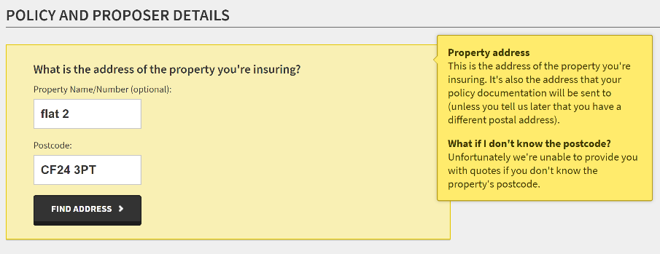

Figure 5: help box. Gocompare.com/home/Start

The additional information is provided automatically to the user without the need to click on any button, in the attempt to predict the user’s needs and save time.

## Consistency of Exemptions

On click of the “back to quotes” buttons, the user is prompted with a message asking the user to confirm their action (Figure 6).

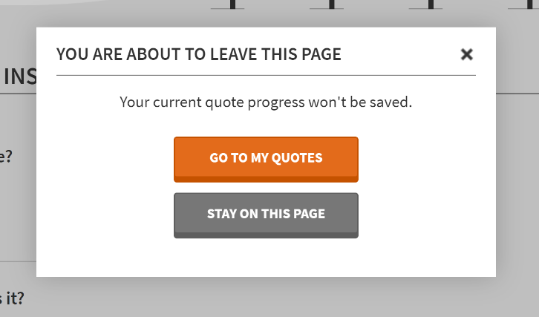

Figure 6: back to quotes confirmation. Gocompare.com/home

The choice here is to provide the same message, whether the user is trying to go back to previous quotes, to sign out or to go back to the home page. The confirmation messages keep a uniform style, with a little diversion in colour and invite the user to read the options before proceeding.

When dealing with home insurance (and comparison websites more in general), the design must consider the need to produce more than one quote per user. This means predicting the needs of returning customers enabling and facilitating the user login in. In the case of a returning customer trying to start a new quote, the web site prompts the user to enter their password upon the recognition of the details entered in the first page (Figure 7).

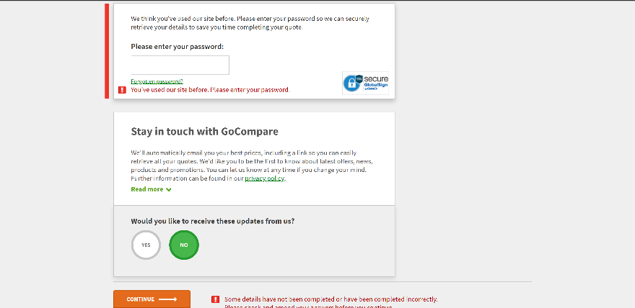

Figure 7: password request for returning users. Gocompare.com/home/Start

This is done by using an error message prompting the user to enter their chosen password. The screen scrolls automatically up to the password form field where another line of text is displayed in red. The message is contained in the same page without the need to redirect the user to the login page. This allows to keep the user focused on the new quote and saves time, as the user can click on the continue button displayed just underneath the form field after entering the password.

## Notes for Implementation

* In the Desktop version of the Go Compare Index page, the user is introduced to a landscape-oriented view of the screen where the content takes up the whole space. The first reaction as a user who as completed a form, is to search for the progress buttons on the bottom right corner of a web page, whilst the back buttons are usually found on the bottom left corner. The first continue button encountered on the GoCompare website is used to direct the user’s attention to the cookie policy and it’s placed on the bottom right corner of the index page. This convention is not respected in the following pages of the UI, where the Continue button is placed dangerously close to the Back button in the bottom left of the page. This can be confusing for the customer and can lead to mistakes (Figure 8).



Figure 8: back and continue button are very close to one another. Gocompare.com/home

* The colour choice of the Continue button can also lead to confusion (Figure 9), as it is on the scale or red, whilst positive feedback to the user throughout the UI is usually highlighted using green. This choice appears to be dictated by the fact that the other button components of the UI used to answer questions regarding the property needed, become green with a white text when selected. One way to overcome this issue would be to add a green tick symbol to a plain selected button, which would allow us to use the green filling and white text for the Continue buttons (Figure 10).

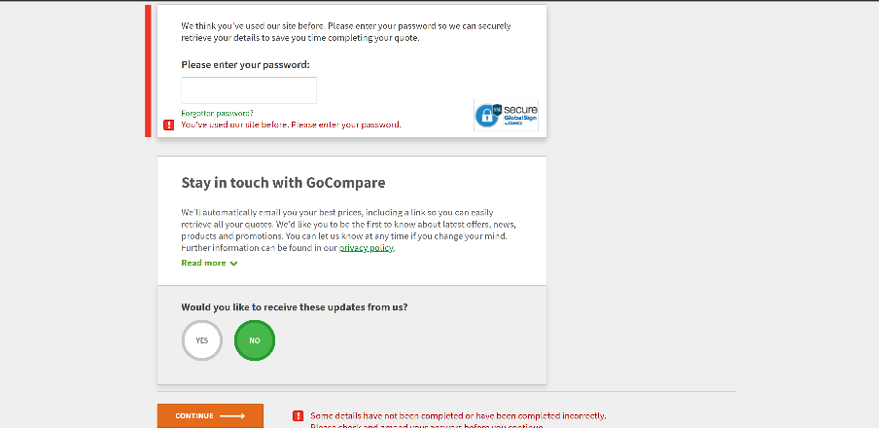

Figure 9: continue button and error messages have similar colours. Gocompare.com/home

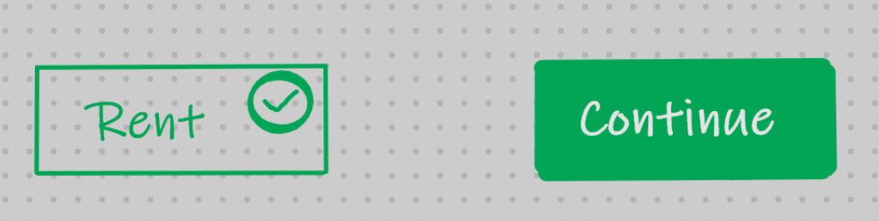

Figure 10: two different kinds of filling for each type of button.

* Below is an example of the new basic structure of the Home Insurance UI (Figure 11). The new UI aims to make a better use of the space and spread elements across the screen rather than justifying the page to the left (Figure 12).

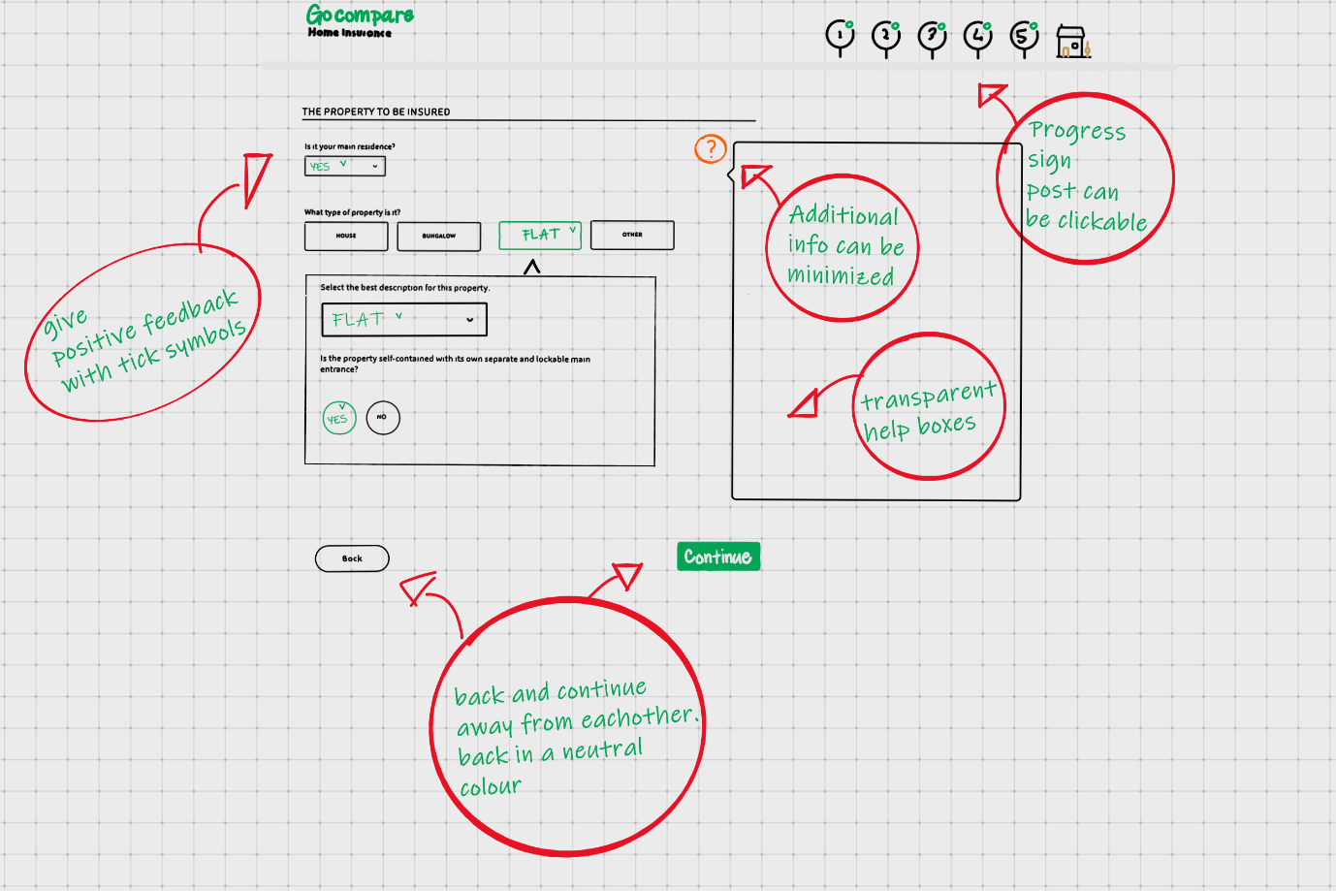

Figure 11: new basic structure of the Home Insurance UI.

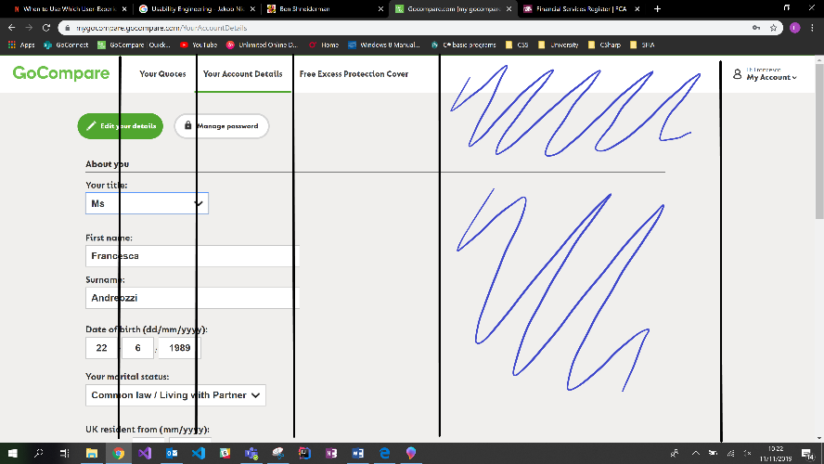

Figure 12: the original Home Insurance UI leaves white spaces which can be distracting and not aesthetically pleasing. Gocompare.com/Your Account Details

# Seek Universal Usability

This section analyses the level of universal usability and how different types of users could interact with the Home Insurance interface.

## Accessibility

This section analyses some of the fundamental elements which define the level of accessibility of the UI.

### Page Titles

The page titles are clear and concise. They all start with a reminder to the Home Insurance followed by the detail of progression. This is important for the user to orientate within the open windows, but most importantly the page title is the first element read by the reader software when the user enters a new page [3]. (Figure 13)



Figure 13: example of page title.

### Alt Text

Every image and logo are marked by the “alt” markup. This markup is used to convey the content of an image to both users who are visually impaired and users with a slow connection who have turned off images [3]. Throughout the Home Insurance online journey, all the images are marked by the “alt” markup followed by a detailed explanation of the content (Figure 14).



Figure 14: Alternative text example.

### Headings

Headings are conventionally used to provide a visual separation between sections. They are useful for people who are not able to use the mouse [3]. The Home Insurance UI makes use of the <div> tag to create visual separations and contain the functional HTML elements of each section.

### Zoom Text Only

Text only Zoom tools are used by people with visual impairments [3]. When using the Google Chrome text only zoom extension on the Home Insurance UI, the text responds correctly in most cases. It resizes automatically and keeps the content formatted.

However, the form fields keep the original size(Figure 15), which causes the loss of parts of the content as shown in the screenshots below, and the top logo and progression bar lose their formatting and clutter the page (Figure 16).

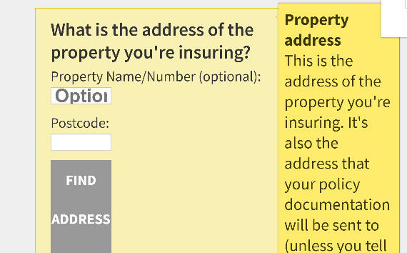 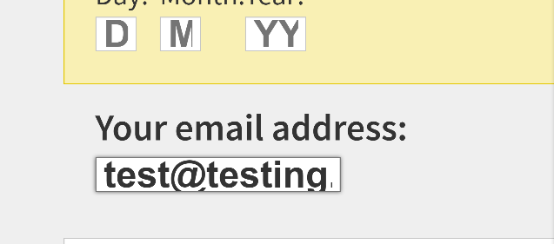

Figure 15: Form field size does not update. Gocompare.com/home/Start

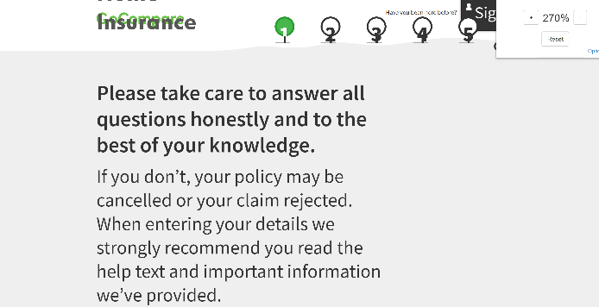

Figure 16: Text image is covered by the zoomed text. Gocompare.com/home/Start

### Keyboard Access

The Home Insurance UI is responsive to keyboard access and allows the user to navigate the pages with the sole use of the “tab” key to move across the elements of the pages. This is important for people who cannot use their mouse, people who are visually impaired or have mobility impairments.

### Moving Content

Moving content can be distracting for users with attention deficit or visual processing disorders [3]. In the Home Insurance UI, content is kept minimal except for the help boxes which appear automatically when the user hovers over the relevant question. The user is not in control and is not able to minimize the help boxes if needed.

### Novice vs Expert Users

Novice users are provided with additional information when hovering over the relevant questions. At the bottom of the page, users are also provided with an “Insurance Jargon Buster”, in the form of external link which opens in a new window. This allows the user to keep the quote page open to avoid confusion. In the case of returning customers, users are facilitated into signing in if they try to start a new quote. For experienced users there is the option to sign in after landing on the index page and start a new quote directly from their account.

### Notes for Implementation

There are a few points to be noted which could improve accessibility.

* Links should be provided with a suitable explanation. This would provide more information to those who use readers. For example, the link to the “Insurance Jargon Buster”, could invite the user to click on the link as follows: “If you want more details about the vocabulary used so far click on our Insurance Jargon Buster”.
* The combination of green and yellow can be hard to detect for colour blind people. The help boxes could instead be white. This would still attract the user’s attention as the help boxes are the only element on the page that moves (Figure 17).

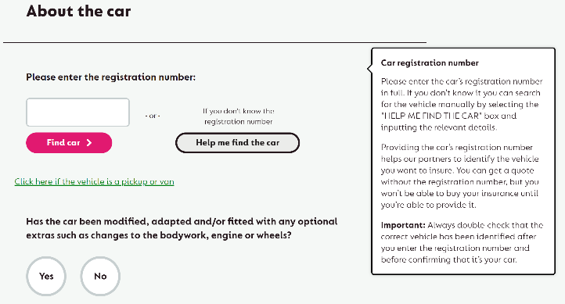

Figure 17: example of white help box from the Car journey https://car.gocompare.com/vehicle

* Most links have a small clickable area. Clicking small links could be difficult for users with mobility issues. This can be done easily with CSS [4]. A few examples can be found at the bottom of the page as shown below (Figure 18).



Figure 18: links with small clickable areas Gocompare.com/home

* The Zoom Text Only feature can be improved with the use of flexible design, to avoid constraining the size of containers and creating text content without the use of images [5].

# Offer Informative Feedback

## Minor and frequent actions

The Home Insurance UI provides a basic level of feedback to the user throughout the journey. For minor actions like the selection of a button the user receives affirmative feedback using the colour green. However, there is no feedback for the completion of the form fields. This makes it harder for the user to quickly scan through the form and differentiate a blank form field from a correctly completed one (Figure 19).

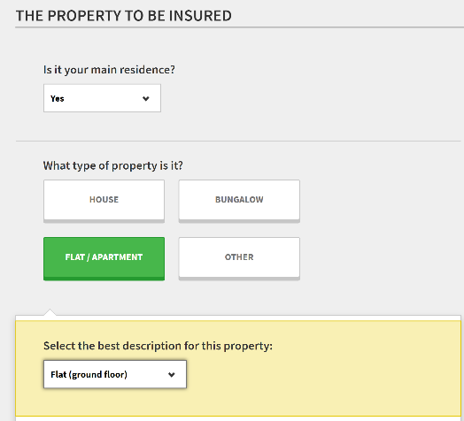

Figure 19: the feedback is inconsistent for completed form fields which stay grey. Gocompare.com/home/Quote

The user is provided with a progression bar at the top of the page, where circled numbers are ticked off anytime the user completes a new page. This style could be integrated as affirmative feedback on completion of a form field to provide a visual stimulus to the user when scanning through the form.

## Major and infrequent actions

When clicking on “sign out”, “back to my quotes”, or on links that redirect to the index page, the user is prompted with pop up messages which ask for confirmation. The messages suggest to the user that the progress made so far will be lost and give the option to stay on the page.

Error messages are triggered only on click of the “Continue” button and prevent the user from progressing to the next page (Figure 20).

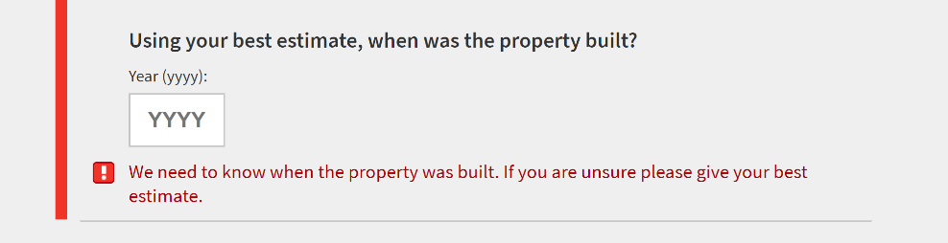

Figure 20: example of error message. Gocompare.com/home/Property

## Notes for Implementation

* Error messages could be displayed when the user clicks off the form field. This would allow the user to correct the mistake before trying to progress to the next page. When the user clicks on the continue button and the web site detects an error, the page automatically scrolls to the relevant section. In this case the user needs to read the question in full again in order to orientate and answer. By giving immediate feedback the user does not need to go through the question a second time, making the process more efficient.
* When click on the button “Find Address” a message informs the user that several addresses have been found under the same post code. The message should be modified following a more consistent style (Figure 21).

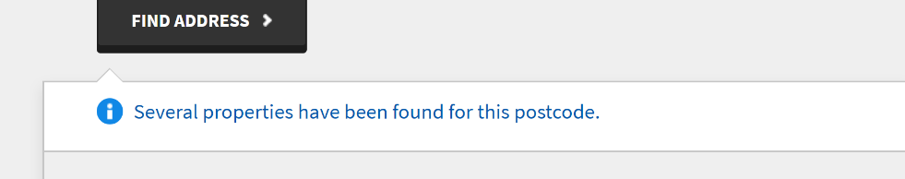

Figure 21: the message doesn't respect the style used so far for feedback. Gocompare.com/home/Start

# Design Dialogs to Yield Closure

Insurance quotes are composed of a series of questions which can be at times daunting for users. It is important to provide an element visible across all pages of the application, which can remind the user of the progress made so far.

## Sign Posts

The Home Insurance online journey is divided in five sections. The progress is provided to the customer by sign-post elements on the top right of the page, which are ticked off anytime the user completes a whole page and clicks on continue (Figure 22).

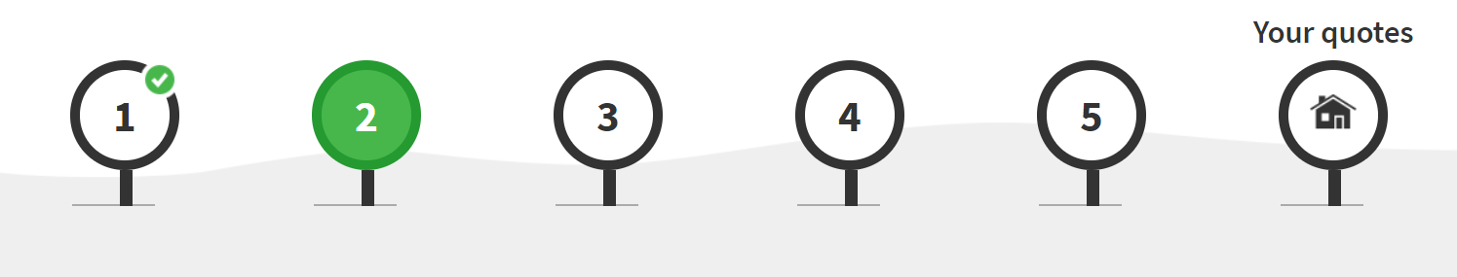

Figure 22: sign-posts used for feedback. Gocompare.com/home

Whilst the sign-post is a useful tool to encourage the user throughout the application, it is also a dead end in terms of functionality. The main issue is the fact that the five sections are not grouped under a group name although they have a thematic structure.

## Quote Completion

When a quote is completed, the user is presented with a list of different providers and prices. Once the relevant cover is selected, the user can navigate the “Your Cover Summary” page.

The menu bar on the left side of the page provides all the important information grouped into thematic groups (Figure 23). The price of the selected cover and the links to proceed with the purchase (online or offline) are always visible to the user.

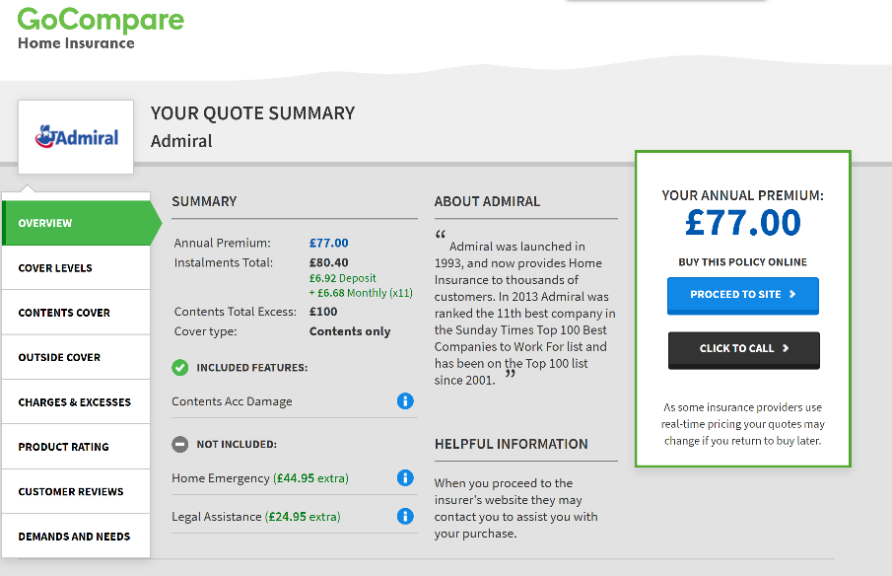

Figure 23: interactive side menu organised in thematic structure Gocompare.com/home/Results

When the user clicks on “Proceed to site”, the user is redirected to the website of the selected Company. Whilst this happens, a loading page informs the user that they are being redirected. The page also informs the user that they are leaving the domain of GoCompare with a thank you message.

## Note for Implementation

* The page titles could be used as sign posts instead of the numbers from one to five. This would be a reminder to the user of what has so far been completed, but also an indicator for the next group of information required.
* The sign-posts should be clickable links. The user should be able to go back and forth within the different sections without having to repeatedly click on the “back” button.

# Prevent Errors

When completing the online form to obtain home insurance quotes, the user is provided with numerous tools which aim to prevent errors.

## User Input Validation

User inputs are controlled by only allowing specific characters into the relevant form fields. For example, when entering first name and surname, numeric characters or symbols are not recorded in the fields when typed. The date of birth follows the same logic, where alphabetic characters are not allowed.

When the user inputs an email address, all symbolic and alphanumeric characters are allowed, but the UI recognises the lack of the @ symbol and displays an error message, which prompts the user to enter a valid email address.

Other responsive form fields like the post code give immediate feedback when not completed or completed with invalid inputs. The postcode only allows the user to only enter alphanumeric values.

In addition, user inputs are also controlled with the use of multi-choice questions. The options given are set in response to the previous answers given. As shown in the screenshot (Figure 24), the options change according to the previous answer. This restricts the possibility of errors and saves user’s time.

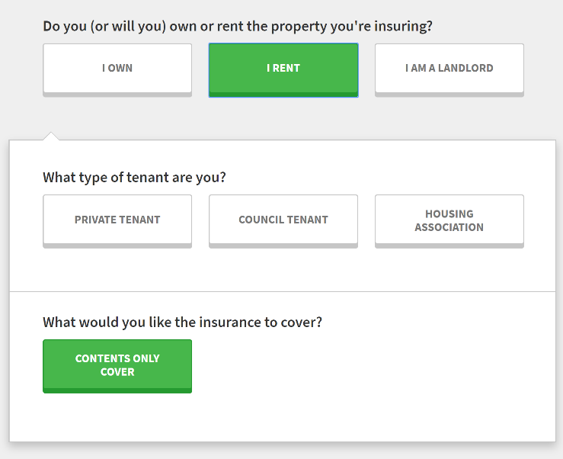

Figure 24: buttons are preselected to avoid mistakes. Gocompare.com/home/Start

## Error Messages

When users make an error, a red line is displayed to the left of the relevant section whilst the error message is displayed at the bottom. Error messages keep the minimalistic style of the UI to avoid creating stressful warnings and cluttering the page (Figure 25).

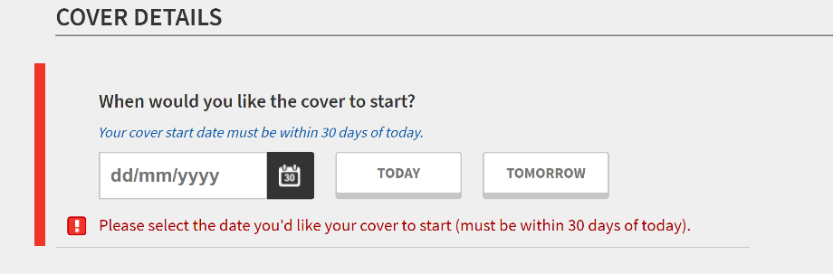

Figure 25: example of error message. Gocompare.com/home/Cover

The error messages are very specific to each relevant section they refer to. They provide the users with additional information and state the reason why the information is necessary to progress. When an error message is displayed the page does not discard the input previously entered by the users, allowing them to correct the fault (Figure 26).



Figure 26: the day and month are not discarded and don't need to be entered again. Gocompare.com/home/Policyholder

## Notes for Implementation

* When entering an incorrect value in the date of birth field, if the user enters only one numeric value in the year box, the missing values of the year are automatically filled in. This can lead to mistakes as the users are not in control of the year they chose (Figure 27). This should be solved by triggering an error message if less than four numeric values are entered under year.

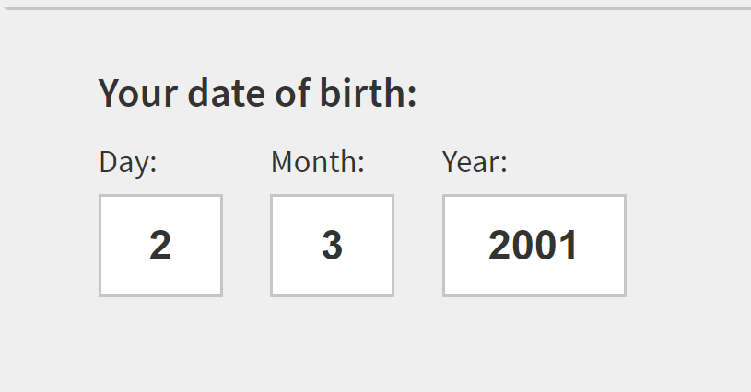

Figure 27: when entering the value 1 in the year form field, 2001 is automatically populated.

# Permit Easy Reversals of Actions

The Home Insurance UI offers full mobility of choice to the users. Form fields can be completed and deleted, and drop-down menu selections can be deselected.

When users select an answer in a multi-choice question, their choice can be updated by clicking on a different option. Th UI does not give the option to undo the selection without providing a new one.

Users can manage and change their details by clicking on the “My Account” section. The form to change password is very easy to access and complete.

## Notes for Implementation

* The addresses provided to the user after entering a postcode are hardcoded and cannot be modified. Users should be able to enter their address manually if the correct address is not automatically found in the dropdown menu.

# Keep Users in Control

Experienced users are presented with a UI that allows them to quickly find all the links necessary to manage or edit their profile and their quotes. They can keep track of their quotes history as they sign in and are able to delete quotes by clicking on the “x” symbol on the top right corner of the individual quote. They are presented with a simple pop up message to confirm their choice. The main links to “Your Quotes”, “Your Account Details” and “Free Excess Protection Cover” are shown in the navigation bar at the top of the page and reiterated in the drop-down menu under the “My Account” logo, which makes it quicker for an experienced user to find. From the “Your Quotes” page, it’s also possible to jump directly to other types of insurance quotes. This saves time for users who wish to complete more than one quote without having to go through the home page.

The process to manage the passwords is also available under the user’s profile and only requires the user to enter the current and new password.

In the “Your Quotes” page, users can click on the “new quote” button to automatically start a new quote. The application remembers the details previously entered, so users can quickly progress through the quote by clicking on continue.

## Notes for Implementation

* Every user is provided with a link to the “Free Excess Protection Cover”, which allows the customer to make a claim in case they purchase a car insurance. Although this is useful for advertising the car insurance, providing the link to all users can be confusing, as they would click on the link thinking they have to complete the form.
* Users should be allowed to start a new quote from scratch. This can be achieved by adding a “Start Empty Quote” button under the one that offers the link to a new quote.
* On the login page users must enter their date of birth, which is never stored in the form field. This can be time consuming and tedious for users who share computers and have to logout after every session. Users should not be asked to enter their date of birth which seems like a redundant detail.

# Reduce Short Term Memory Load

## Thematic Structure

The Home Insurance UI follows a clear thematic structure. Concatenated questions are shown in the same page. Users do not need to remember details previously entered in order to answer questions in the following pages.

## Existing Details

When users create a profile, the UI stores information in the “My Account” section, where it is possible to edit previously completed quotes or start new ones. Every new quote started from the user profile is prefilled with the information taken from previous quotes.

In the profile section, users can manage their personal details and passwords. The personal details are stored in form fields which can be accessed by simply clicking on the field.

Under “Manage Password”, users can modify their password. In case of forgotten passwords, users can request a new one by clicking on the relevant link. The email address is already preselected as the one provided in the personal details.

## Notes for Implementation

* Some questions can seem repetitive and can confuse the user. Users should be reminded of the information they have entered without having to navigate to the relevant page. This can be achieved by adding a note which refers to the theme of the page on top of the sign posts in the progress bar on the top of the page.
* Users who drop out of the quote before creating a profile currently lose any progress made. This can be solved by implementing quote recovery using cookies.

# Conclusion

The Home Insurance UI targets a wide range of users, which dictates a minimalist style in accordance with the brand’s standards. However, parts of the colour scheme, like the use of orange for continue buttons or yellow for additional information boxes, could be improved. The implementation of new and updated accessibility features is necessary to widen the range of users and improve users’ experience. Existing elements such as sign-posts to indicate progression should be provided with updated functionalities to allow the users to navigate their application more effectively. Features, such as the ability to enter addresses manually or to start a new empty form, need to be implemented. Other features, such as the autocompletion of the date of birth in case a user enters only one number in the form field, should be modified to avoid mistakes. A better use of the space can also be implemented as shown in Figure 11.

# References

|  |  |
| --- | --- |
| [1] | B. Shneiderman, “Ben Shneiderman,” University of Meriland, May 2016. [Online]. Available: https://www.cs.umd.edu/users/ben/goldenrules.html. |
| [2] | L. Thorlacius, “The Role of Aesthetics in Web Design,” *Nordical Review,* vol. 1, no. 28, pp. 63-76, 2007. |
| [3] | S. L. Henry, “World Wide Web Consortium (W3C),” Education and Outreach Working Group, 22 December 2017. [Online]. Available: https://www.w3.org/WAI/test-evaluate/preliminary/#title. |
| [4] | S. Datt, “Webcredible,” Inviqa, 06 December 2010. [Online]. Available: https://www.webcredible.com/blog/increase-clickable-area-links-using-css/. |
| [5] | U. o. Washington, “Supporting Enlarged Text,” University of Washington, 2019. [Online]. Available: https://www.washington.edu/accessibility/checklist/zoom/.  https://www.gocompare.com/home/Start |